TITLE; NO BLANK LINE BETWEEN THE TITLE AND THE PAPER TOP MARGIN CAPITAL LETTERS; PAGE-CENTERED; MAX. 2 LINES/70 TOTAL CHARACTERS

Forename Surname, University, name@domain.com
Forename Surname, University, name@domain.com

- Introduction
These instructions are intended to guide contributing authors in preparing abstracts for review at International Conference on Asian and Pacific Coasts 2027. Please submit your abstract in PDF format. Although individual contributions may differ from the general format shown here, please read these instructions carefully and use this document as a template when preparing your abstract.

- Format Instructions
The abstract must not exceed 2 pages, including figures, tables, equations, and references. Retain Letter paper size, 21.6 x 27.9 cm (8.5 x 11 in), with 2.54 cm (1 in) margins on all sides. Use 12 pt Times New Roman throughout, including figure captions. Metric units of measure should be used in all instances (colloquial units allowed in parentheses, as above).
Type the paper title in bold, upper-case letters and center it. Leave one blank line below the title before the author names, affiliations, postal addresses, and email addresses. Use superscript numbers to link each author to the appropriate affiliation. Identify the corresponding author with an asterisk and provide a contact email. Replace the sample author information above with your own details.

- Headings
Use bold headings in upper- and lower-case letters, with one blank line above each heading. Present the research objective, methods, principal results, and conclusions clearly.

- Tables, Figures, Equations and References
Place tables and figures immediately following their first citation in the text, or, on the next full page if space is limited. Leave one blank line above and below each table. Place table headings above the tables and number tables consecutively. If the table heading extends over one line, continue on the second and following lines immediately below the first letter of the heading. Use horizontal lines above and below the table and below column headings. Use clear column headings and state units where applicable. Table 1 illustrates the layout only; replace it with your own data or remove it.

Table 1. Example of a legible table
Direction | First | Second | Third | Fourth
East | 20.4 | 27.4 | 90.0 | 20.4
West | 30.6 | 38.6 | 34.6 | 31.6
North | 45.9 | 46.9 | 45.0 | 43.9

Color figures are allowed. Number figures consecutively and place captions below them. Leave one blank line above each figure and after its caption. For multi-line captions, align subsequent lines with the first letter of the caption text. Do not place a full stop at the end of table headings or figure captions. Ensure all labels, legends, scales, and symbols remain legible at the final size. Replace the example figure with your own material or remove it. The abstract should preferably contain no more than 3 figures and tables in total.

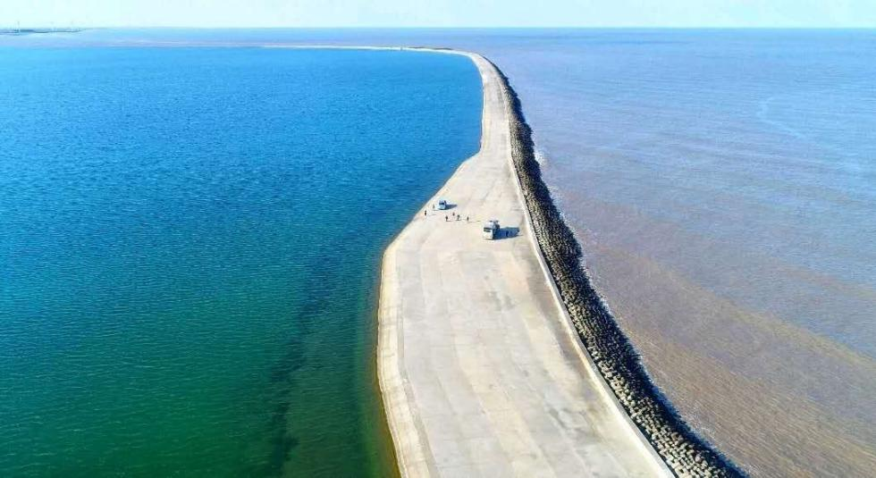

Figure 1. The Two-Color Sea Embankment at Qidong, Jiangsu

Use editable equations where possible. Number equations consecutively, place equation numbers at the right margin, and define all symbols at their first occurrence. An example is shown below.
$\frac{X}{L}≤48(1-K_{t})\frac{H_{0}}{D}$ (1)
where X = structure length; L = wavelength; K_{t} = transmissivity; H₀ = deep water wave height; and D = water depth.
For citations of references, we prefer the use of square brackets and consecutive numbers. Citations using labels or the author/year convention are also acceptable. The following bibliography provides a sample reference list with entries for journal articles [1], an LNCS chapter [2], a book [3], proceedings without editors [4], as well as a URL [5].

Acknowledgements
We appreciate the cooperation and efforts of all authors contributing to International Conference on Asian and Pacific Coasts 2027. It is an exciting project, and we look forward to receiving your manuscript! For submission, go to https://apac2027china.hhu.edu.cn to upload your abstract in pdf format.

Your filename for submitting your abstract must be lastname_firstname.docx/ lastname_firstname.pdf where you substitute the first author's name in the proper places.

References
- Author F (2016) Article title. Journal 2(5): 99–110.
- Author F, Author S (2017) Title of a proceedings paper. In: Editor F, Editor S (eds.) Proceedings Title, pp. 1–13. Publisher, Location.
- Author F, Author S, Author T (1999) Book title. 2nd edn. Publisher, Location.
- Author F (2010) Contribution title. In: 9th International Proceedings on Proceedings, pp. 1–2. Publisher, Location.
- Author or organization Webpage title. URL, last accessed YYYY/MM/DD.

